5th Grade Weather Lab
Objective:

Earth’s Systems
Students who demonstrate understanding can:
5-ESS2-1. | Develop a model using an example to describe ways the geosphere, biosphere, hydrosphere, and/or atmosphere interact. [Clarification Statement: Examples could include the influence of the ocean on ecosystems, landform shape, and climate; the influence of the atmosphere on landforms and ecosystems through weather and climate; and the influence of mountain ranges on winds and clouds in the atmosphere. The geosphere, hydrosphere, atmosphere, and biosphere are each a system.] [Assessment Boundary: Assessment is limited to the interactions of two systems at a time.]
5-ESS2-2. | Describe and graph the amounts and percentages of water and fresh water in various reservoirs to provide evidence about the distribution of water on Earth. [Assessment Boundary: Assessment is limited to oceans, lakes, rivers, glaciers, ground water, and polar ice caps, and does not include the atmosphere.]
5-ESS3-1. | Obtain and combine information about ways individual communities use science ideas to protect the Earth’s resources and environment.

The performance expectations above were developed using the following elements from the NRC document A Framework for K- 12 Science Education:
Science and Engineering Practices  Developing and Using Models  Modeling in 3–5 builds on K–2 experiences and progresses to building and revising simple models and using models to represent events and design solutions.  - Develop a model using an example to describe a scientific principle. (5-ESS2-1)  Using Mathematics and Computational Thinking  Mathematical and computational thinking in 3–5 builds on K–2 experiences and progresses to extending quantitative measurements to a variety of physical properties and using computation and mathematics to analyze data and compare alternative design solutions.  - Describe and graph quantities such as area and volume to address scientific questions. (5-ESS2-2)  Obtaining, Evaluating, and Communicating Information  Obtaining, evaluating, and communicating information in 3–5 builds on K–2 experiences and progresses to evaluating the merit and accuracy of ideas and methods.  - Obtain and combine information from books and/or other reliable media to explain phenomena or solutions to a design problem. (5-ESS3-1) | Disciplinary Core Ideas  ESS2.A: Earth Materials and Systems  - Earth’s major systems are the geosphere (solid and molten rock, soil, and sediments), the hydrosphere (water and ice), the atmosphere (air), and the biosphere (living things, including humans). These systems interact in multiple ways to affect Earth’s surface materials and processes. The ocean supports a variety of ecosystems and organisms, shapes landforms, and influences climate. Winds and clouds in the atmosphere interact with the landforms to determine patterns of weather. (5-ESS2-1)  ESS2.C: The Roles of Water in Earth’s Surface Processes  - Nearly all of Earth’s available water is in the ocean. Most fresh water is in glaciers or underground; only a tiny fraction is in streams, lakes, wetlands, and the atmosphere. (5-ESS2-2)  ESS3.C: Human Impacts on Earth Systems  - Human activities in agriculture, industry, and everyday life have had major effects on the land, vegetation, streams, ocean, air, and even outer space. But individuals and communities are doing things to help protect Earth’s resources and environments. (5-ESS3-1) | Crosscutting Concepts  Scale, Proportion, and Quantity  - Standard units are used to measure and describe physical quantities such as weight and volume. (5-ESS2-2)  Systems and System Models  - A system can be described in terms of its components and their interactions. (5-ESS2-1),(5-ESS3-1)  - - - - - - - - - - - - - - - - - - - - - - - - - - - - - - - - - - - -  Connections to Nature of Science  Science Addresses Questions About the Natural and Material World.  - Science findings are limited to questions that can be answered with empirical evidence. (5-ESS3-1)

Docent Lab Guidelines:
- Schedule a date and time with your teacher to have the students come into the lab. Allow at least 1 hour of class time. Ideally it would be better if you can get 1hr. 15 min. or 1-1/2 hrs.
- Input the day and time into the Science Lab Master Schedule. Please make sure you add set up and clean up time to the class time.
- Allow 30 minutes to set up and 30 minutes of clean up time.

__________________________________________________________________________________
General Docent Information about the Subject Matter – For Docent Reference
Source: http://www.noaa.gov/resource-collections/weather-atmosphere-education-resources

Informational Videos:
Understanding El Nino https://www.youtube.com/watch?v=_Tuou_QcgxI

Understanding La Nina https://www.youtube.com/watch?v=fAvk4RXrW_E

Student Reference:

Air Pressure
Air pressure is the force exerted on you by the weight of tiny particles of air. The air molecules are invisible, but they still have weight and take up space. Changes in temperature affect how many molecules are packed into the atmosphere.
Warm weather brings low pressure systems:
Warm air expands so there are fewer air molecules in the atmosphere. Low pressure systems usually bring cloudy and rainy days.
How low pressure systems create clouds and rain:
- In the Northern Hemisphere, a low pressure system forces winds to spiral counterclockwise. Air is forced up toward the center of this spiral and has nowhere to go but up.
- As the air rises, it cools (because the atmosphere gets colder as altitude increases).
- Cold air can’t hold as much water vapor as warm air, so the water condenses or comes together, to form clouds
- When the water droplets join together and get too heavy, they may fall as rain or snow (which meteorologists call “precipitation”)
Cold weather brings high pressure systems:
How high pressure systems create clear skies:
- In the Northern Hemisphere, high pressure system winds spiral clockwise, moving from the center outward.
- To replace the air that flows out of the storm’s center, more air is sucked down from up higher in the atmosphere.
- This air warms up as it is pulled down. The warm air expands, and any clouds or precipitation that had formed disappear.
Meteorologists measure air pressure with a barometer.
Cooler air contracts, which means air molecules become smaller and take up less space (so more of them can be packed into the atmosphere). High pressure systems usually bring sunny days.

Experiment#1: Make Lightening
MAKE LIGHTNING
MATERIALS:
- aluminum pie pan
- small piece of wool fabric
- styrofoam plate
- pencil with a new eraser
- thumbtack

PROCESS:
Push the thumbtack through the center of the aluminum pie pan from the bottom
Push the eraser end of the pencil into the thumbtack.
Put the Styrofoam plate upside-down on a table. Quickly, rub the underneath of the plate with the wool for a couple of minutes.
Pick up the aluminum pie pan using the pencil as a handle and place it on top of the upside-down Styrofoam plate that you were just rubbing with the wool.
Touch the aluminum pie pan with your finger. You should feel a shock. If you don’t feel anything, try rubbing the Styrofoam plate again.
Once you feel the shock, try turning the lights out before you touch the pan again. Check out what you see! You should see a spark!!
Please save the supplies for future use.
EXPLANATION:
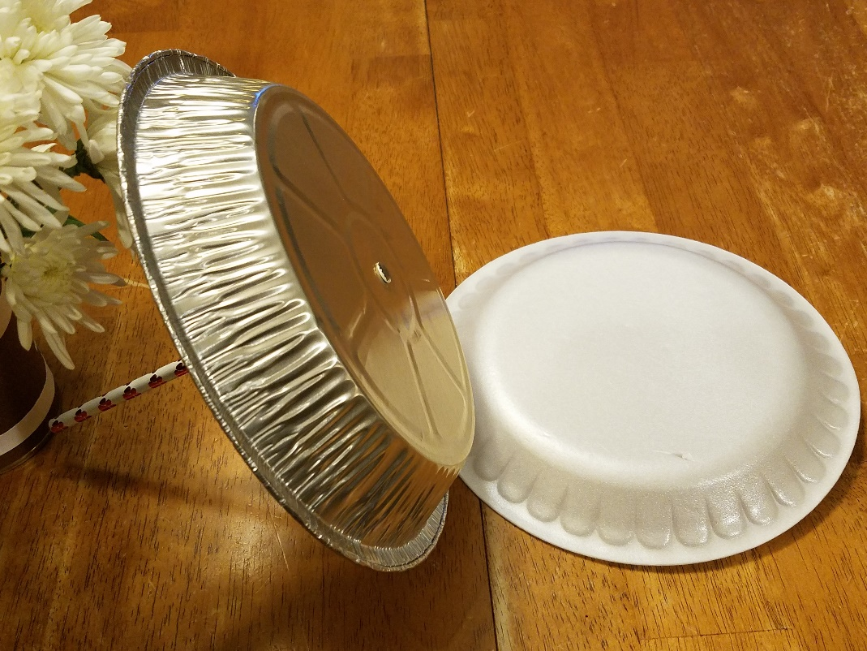
Why does this happen? It’s all about static electricity. Lightning happens when the negative charges, which are called electrons, in the bottom of the cloud or in this experiment your finger are attracted to the positive charges, which are called protons, in the ground or in this experiment the aluminum pie pan. The resulting spark is like a mini lightning bolt.

Experiment #2 Cloud in a Bottle
Make a Cloud in a Bottle
Background: During a rainstorm the air feels moist. On a clear, cloudless day the air may feel dry. As the sun heats the land and the oceans, the amount of water in the atmosphere changes. Water is always moving between the atmosphere and the Earth’s surface. This movement of water between the atmosphere and the Earth’s surface is called the water cycle.

MATERIALS:
- safety glasses
- 5-2liter plastic soda bottles
- 5-foot pumps
- cork
- Rubbing alcohol (less than 1 cup per class)
Docent notes: Foot pump: use silver metal pin release to open; BE CAREFUL it will spring open; Use 5-6 pumps only of air pump; Do not put your face near the mouth of the bottle when removing the cork. After use, store pumps in bottom of box, carefully coil tubing and store it at the top of the box. Please do not bend the needles. Put a small amount of alcohol (less than ¼ cup) in each plastic bottle, and swirl to coat the inside. This has to be done only once per class.
Divide students into groups of 5/6 students: 3 student work while others observe, then switch roles.
Docents demonstrate first
Person 1: holds bottle down
Person 2 Holds valve seal in place
Person 3 pumps the air pump (about 6 times only)
Person 2 gently removes the valve.
A cloud should form in the bottle as the air pressure and the temperature suddenly drop.
Insert the cork back into the mouth of the bottle and pump the air pump 4-5 times, increasing the pressure.
The cloud vanishes due to the increased air pressure, turning the moisture back into liquid.
Second set of students repeats the process.

Debriefing questions:
1. Why is alcohol used instead of water? (answer: alcohol evaporates much more quickly than water and allow us to demonstrate the water cycle easily)
2. Why did we use a pump in this experiment? (answer: to introduce high and low pressure systems into our contained environment)
3. What phase change occurred when the cloud was formed? (answer: liquid to gas)
4. Do you think the answers would be different if the weather outside were different? (snowy, foggy, etc.) (answer: no because we have a contained environment in our bottle)

Experiment #3: Make an Anemometer
This is time consuming and best done in pairs. Perhaps the pair could make another in class at a later time.

MAKE AN ANEMOMETER 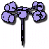
MATERIALS:
- 5 three ounce paper Dixie Cups
- 2 soda straws
- Straight pin
- paper punch
- scissors
- stapler
- sharp pencil with an eraser
PROCESS:
Take four of the Dixie Cups and use the paper punch to punch one hole in each, about a half inch below the rim.
Take the fifth cup and punch four equally spaced holes about a quarter inch below the rim. Then punch a hole in the center of the bottom of the cup.
Take one of the four cups and push a soda straw through the hole. Fold the end of the straw and staple it to the side of the cup across from the hole. Repeat this procedure for another one-hole cup and the second straw.
Slide one cup and straw assembly through two opposite holes in the cup with four holes. Push another one-hole cup onto the end of the straw just pushed through the four-hole cup.
Bend the straw and staple it to the one-hole cup, making certain that the cup faces the opposite direction from the first cup. Repeat this procedure using the other cup and straw assembly and the remaining one-hole cup.
Align the four cups so that their open ends face in the same direction either clockwise or counter-clockwise around the center cup.
Push the straight pin through the two straws where they intersect.
Push the eraser end of the pencil through the bottom hole in the center cup. Push the pin into the end of the pencil eraser as far as it will go.
Now your anemometer is ready for use!
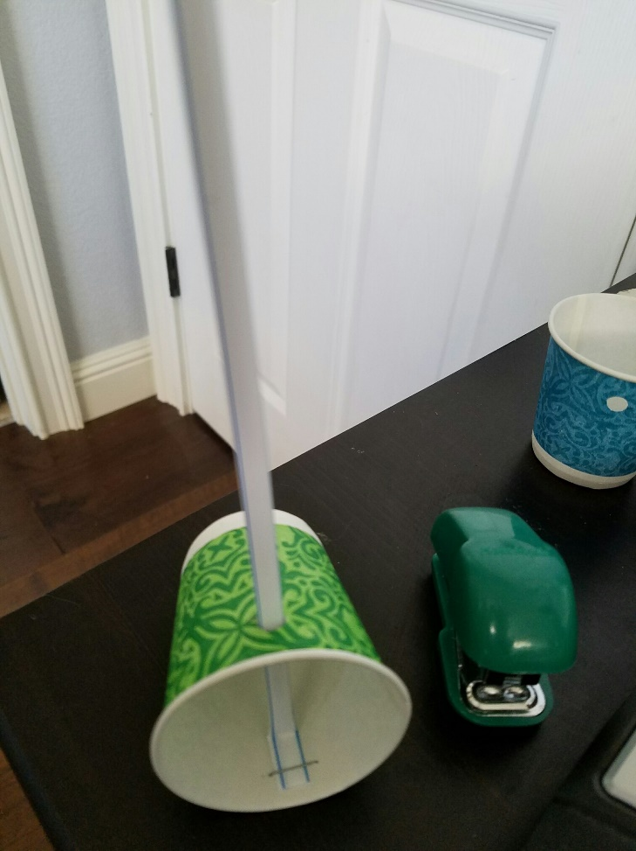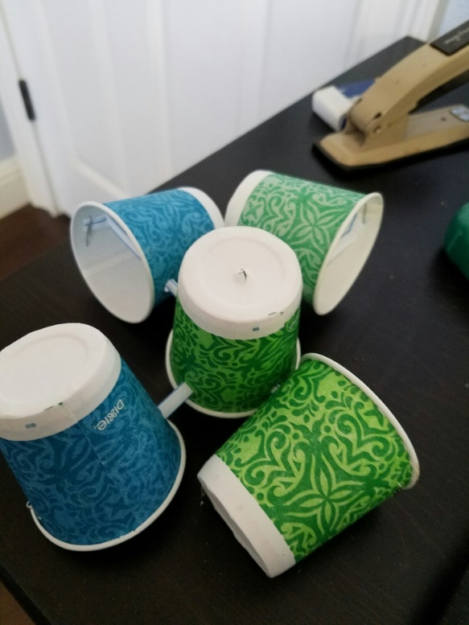
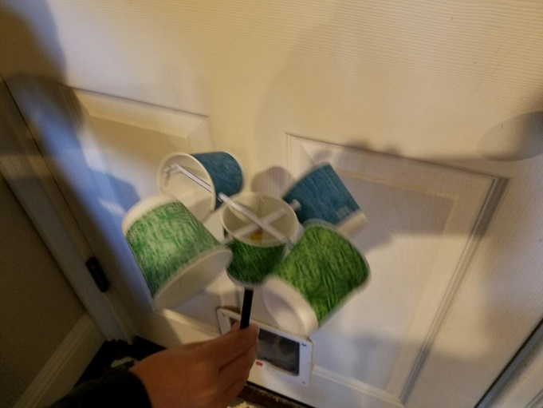EXPLANATION:
An anemometer is useful because it rotates with the wind. To calculate the velocity at which your anemometer spins, determine the number of revolutions per minute (RPM). Next, calculate the circumference (in feet) of the circle made by the rotating paper cups. Multiply your RPM value by the circumference of the circle and you will have an approximation of the velocity of at which your anemometer spins (in feet per minute). Your anemometer doesn't need to be pointed in the wind for use.
Note: Some forces are being ignored including drag and friction for this elementary illustration, so the velocity at which your anemometer spins is not the same as wind speed.

Calculation:
Velocity (feet per minute) = revolutions per minute x 2 (approximate circumference in feet made by the rotating cups)

