***5tht Grade – Cells Part 2***

**Objective:**

Students will learn and compare the part of a plant and animal cells by making a model of each.

|  |  |  |
| --- | --- | --- |
| |  | | --- | | [**LS1.A: Structure and Function**](http://www.nap.edu/openbook.php?record_id=13165&page=143)   * [*All living things are made up of cells, which is the smallest unit that can be said to be alive. An organism may consist of one single cell (unicellular) or many different numbers and types of cells (multicellular). (MS-LS1-1)*](http://www.nap.edu/openbook.php?record_id=13165&page=143) * [*Within cells, special structures are responsible for particular functions, and the cell membrane forms the boundary that controls what enters and leaves the cell. (MS-LS1-2)*](http://www.nap.edu/openbook.php?record_id=13165&page=143) * [*In multicellular organisms, the body is a system of multiple interacting subsystems. These subsystems are groups of cells that work together to form tissues and organs that are specialized for particular body functions. (MS-LS1-3)*](http://www.nap.edu/openbook.php?record_id=13165&page=143) | |  |

**Docent Lab Guidelines:**

1. Docent(s) should plan to arrive early to set up before the class arrives.
2. Input the day and time into the Science Lab Master Schedule. Please make sure you add 15 minutes of set up time and about 15 minutes of clean up time to the overall class time.
3. Safety glasses are not required for this lab but aprons can be worn to protect clothes but are not required.
4. Give a brief 5 overview of plant and animal cells. You can also opt to play a short video. These are listed below.
5. Allow enough time at the end for students to wash up afterwards. Girls can wash up in the adjacent girl’s restroom.
6. The last 5-10 minutes of class review with the students their observations.

**Plant & Animal Cells by** *Biology for Kids*

***(For Docent’s Reference Only)***

All living organisms on Earth are divided into **cells**. The main concept of **cell theory** is that cells are the basic structural unit for all organisms. Cells are small compartments that hold the biological equipment necessary to keep an organism alive and successful. Living things may be single-celled or they may be very complex such as a human being.   
  
There are smaller pieces that make up cells such as **macromolecules** and **organelles**. A protein is an example of a macromolecule while a [**mitochondrion**](http://www.biology4kids.com/files/cell_mito.html) is an example of an organelle. Cells can also connect to form larger structures. They might group together to form the **tissues** of the stomach and eventually the entire digestive **system**. However, in the same way that atoms are the basic unit when you study matter, cells are the basic unit for biology and organisms.   
  
In larger organisms, the main purpose of a cell is to **organize**. Cells hold a variety of pieces and each cell type has a different **purpose**. By dividing responsibilities among different groups of cells, it is easier for an organism to survive and grow.   
  
If you were only made of one cell, you would be very limited. You don't find single cells that are as large as a cow. Cells have problems functioning when they get too big. Also, if you were only one cell you couldn't have a [**nervous system**](http://www.biology4kids.com/files/systems_nervous.html), no [**muscles**](http://www.biology4kids.com/files/systems_muscular.html) for movement, and using the internet would be out of the question. The trillions of cells in your body make your way of life possible.

**One Name, Many Types**

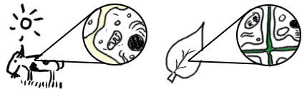

There are many types of cells. In biology class, you will usually work with **plant-like** cells and **animal-like** cells. We say "animal-like" because an animal type of cell could be anything from a tiny [**microorganism**](http://www.biology4kids.com/files/micro_main.html) to a nerve cell in your brain. Biology classes often take out a microscope and look at single-celled microbes from pond water. You might see hydra, amoebas, or euglena.   
  
Plant cells are easier to identify because they have a protective structure called a [**cell wall**](http://www.biology4kids.com/files/cell_wall.html) made of cellulose. Plants have the wall; animals do not. Plants also have organelles such as the green chloroplast or large, water-filled [**vacuoles**](http://www.biology4kids.com/files/cell_vacuole.html). Chloroplasts are the key structure in the process of **photosynthesis**.

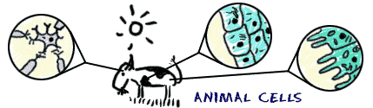

Cells are unique to each type of organism. If you look at very simple organisms, you will discover cells that have no defined nucleus ([prokaryotes](http://www.biology4kids.com/files/micro_prokaryote.html)) and other cells that have hundreds of nuclei (multinucleated).   
  
Humans have hundreds of different cell types. You have red blood cells that are used to carry oxygen (O2) through the body and other cells specific to your heart muscle. Even though cells can be very different, they are basically compartments surrounded by some type of [membrane](http://www.biology4kids.com/files/cell_membrane.html).

# Cell membrane is like a plastic bagCell Membranes

According to **cell theory**, cells are the main unit of organization in biology. Whether you are a single cell or a blue whale with trillions of cells, you are still made of cells. All cells are contained by a **cell membrane** that keeps the pieces inside. When you think about a membrane, imagine it is like a big plastic bag with some tiny holes. That bag holds all of the cell pieces and fluids inside the cell and keeps any nasty things outside the cell. The holes are there to let some things move in and out of the cell.

**Flexible Containers**

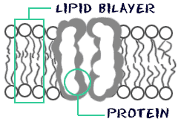The cell membrane is not a solid structure. It is made of millions of smaller molecules that create a flexible and porous container. **Proteins** and **phospholipids** make up most of the membrane structure. The phospholipids make the basic bag. The proteins are found around the holes and help move molecules in and out of the cell. There are also proteins attached to the inner and outer surfaces of the membrane.   
  
Scientists use the fluid mosaic model to describe the organization of phospholipids and proteins. The model shows you that phospholipid molecules are shaped with a head and a tail region. The head section of the molecule likes water (**hydrophilic**) while the tail does not (**hydrophobic**). Because the tails want to avoid water, they tend to stick to each other and let the heads face the watery (**aqueous**) areas inside and outside of the cell. The two surfaces of molecules create the **lipid bilayer**.

**Ingrained in the Membrane**

What about the [**membrane proteins**](http://www.biology4kids.com/files/cell_membprot.html)? Scientists have shown that many proteins float in the lipid bilayer. Some are permanently attached while others are only attached temporarily. Some are only attached to the inner or outer layer of the membrane while the transmembrane proteins pass through the entire structure. The transmembrane proteins that cross the bilayer are very important in the [**active transport**](http://www.biology4kids.com/files/cell2_activetran.html) of ions and small molecules.

**Videos on Cells:**

**Plant and Animal Cell Overview: The Basics (Run time 9 min. 17 sec.) – this video is better for docent reference rather than for the students**

<http://www.neok12.com/video/Cell-Structures/zX78560f5a7d46606c6c5467.htm>

**Parts of an Animal Cell (run time 4 min. 53 sec.)**

<http://www.neok12.com/video/Cell-Structures/zX74425c036360566e584741.htm>

**Parts of a Plant Cell (run time 2 min. 56 sec.)**

<http://www.watchknowlearn.org/Video.aspx?VideoID=20219&CategoryID=5856>

**A fun Music Video to play while students are working:**

**Cells Cells: Parts of a cell rap (run time 3 min. 8 sec.)**

<https://www.youtube.com/watch?v=-zafJKbMPA8>

**Experiment: Making a plant and Animal Cell Model**

**Materials:**

* Playdough in a variety of colors
* Variety of candy
* Variety of dry pasta
* Toothpicks
* Plastic wrap
* Scissors
* Scotch tape
* School glue
* Plastic knives and/or craft sticks
* Paper plates
* Plant and animal part labels
* Laminated plant and animal cell diagrams for reference

**Preparation:**

1. Place all the materials in one area of the lab. Students will pick out their own supplies. Or the docents can divide the supplies among the tables.
2. Place plant and animal cell labels, tape, toothpicks and scissors on the tables.
3. Place diagrams of plant and animal cells on the tables for reference.

**Instructions:**

1. Students will make a plant or an animal cell using playdough as the main base for the model. They can either create the interior structure of the cell with playdough or use any of the provided materials.
2. Make the model on the paper plate.
3. Use the provided labels to label each part of the cell. Attach label to the toothpick with scotch tape and insert into the playdough.
4. Student are to write their name and teacher’s name on their plates.
5. Students will take their cell models home with them. Unfortunately, because of the candy the cells models cannot be displayed in the classroom or they will attach insects.

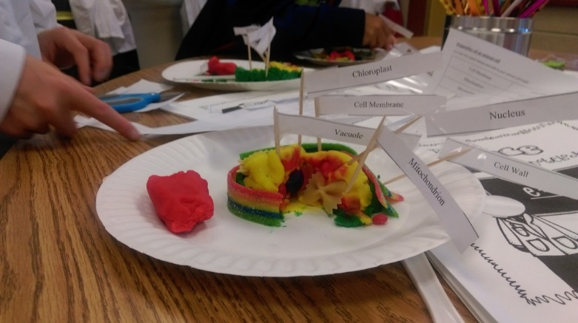[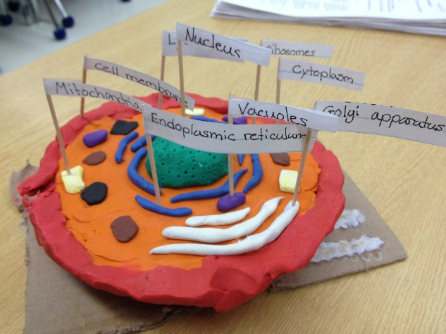](https://www.google.com/url?sa=i&rct=j&q=&esrc=s&source=images&cd=&cad=rja&uact=8&ved=0ahUKEwj28qrIkonPAhVM4iYKHQU0AdUQjRwIBw&url=https://www.tes.com/lessons/OhFWnB8Y0p62Pw/project-cell-model&bvm=bv.132479545,d.dmo&psig=AFQjCNEyABRIC6Xi_nyC2xzjIi2aCJ-BWg&ust=1473746194844807)

**Helpful Tips noted from Previous Classes:**

The following tips are based on doing this experiment with the 5th graders for the first time in October 2015.

1. Set up and cleanup is easy.
2. We found it was easier to set up one table in the front of the class with supplies. Each type of candy and pasta went into a separate container. Students came up and selected their own supplies.
3. Since there was only a limited amount of playdough we found it best to hand out premeasured lumps of red, yellow and green playdough. One lump of playdough for each student. Students can mix their playdough to create new colors if they want.
4. Students needed help figuring out how to attach the paper labels to the toothpicks with scotch tape.
5. We played the Cells Cells rap song the last 10 minutes of class. It was a big hit.
6. Make sure any remaining candy is placed in Ziploc bags. This prevents insects from coming into the lab.