Science Docent 4th grade
Electricity

NextGen Science Standards: 4-PS3-2.Make observations to provide evidence that energy can be transferred from place to place by sound, light, heat, and electric currents 4-PS3-4. Apply scientific ideas to design, test, and refine a device that converts energy from one form to another.* [Clarification Statement: Examples of devices could include electric circuits that convert electrical energy into motion energy of a vehicle, light, or sound; and, a passive solar heater that converts light into heat. Examples of constraints could include the materials, cost, or time to design the device.]

Docent Guidelines:

1. There are 3 separate activities available for this lab session. Estimated time to do all three is 2-2.5 hours. Check with the teacher to see how much time they want the class to spend in the lab then decide which activities to do. The 3 activities are:
--Sparky's Light Kit and (Optional) Insulator/Conductor test, estimated time 30-40 minutes
--Squishy Circuits (building a circuit with dough), estimated time 30 minutes
--Build a simple circuit board , estimated time 50-60 minutes (instructions in separate document)

2. Schedule a time and date with the teacher and input the time into the Science Lab Master Calendar. Remember to include 30 minutes of set up and 30 minutes of clean up time.
3. After a short introductory review, the students will work in groups of 3-4. The order of activities is up to you. One worksheet/instruction sheet per group. (There is no worksheet for Squishy Circuits.)
4. Some notes about Sparky’s Light Kit: The challenge is to get a lightbulb to light using only a battery and a paper clip. You may substitute a sheet of tinfoil for the paper clip as pictured. This video shows how to make the light bulb light (but don’t show this to the kids—let them figure it out): https://www.youtube.com/watch?v=jTNJbLCnLFg
Photo of set up for Sparky’s Light Kit (one set of materials per group)
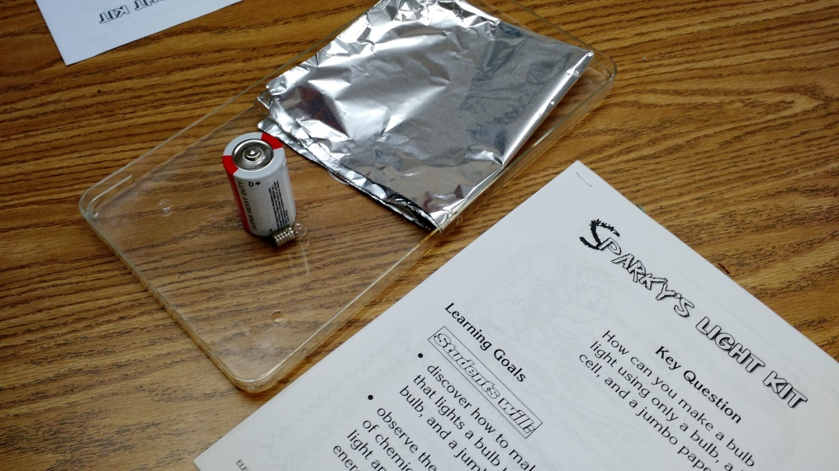

Background Introduction:

Review Vocabulary
Electric current—flow of electrical charges
Conductor—materials that let charges flow through them easily (copper, silver)
Insulator—materials that do not let charges flow easily (rubber, plastic, glass)
Circuit—path along which electric current flows (draw a picture)
Simple circuit—has 3 basic parts: power source, connectors, switch
Closed circuit—complete and unbroken, electricity flows through
Open circuit—has breaks or openings, so electricity does not flow through
Series circuit—all charges flow in the same direction
Parallel circuit—has branches or splits, currents flows along more than one direction
Electrical charge—a property of matter concerning positively and negatively charged particles
Voltage—strength of power source
Resistance—ability to slow down current
Short circuit—has no resistance, so it can be dangerous and stop working
Circuit board—a sheet of insulating material used for the mounting and interconnection of components in electronic equipment
Electric energy is used all around us to create heat, light, and motion!
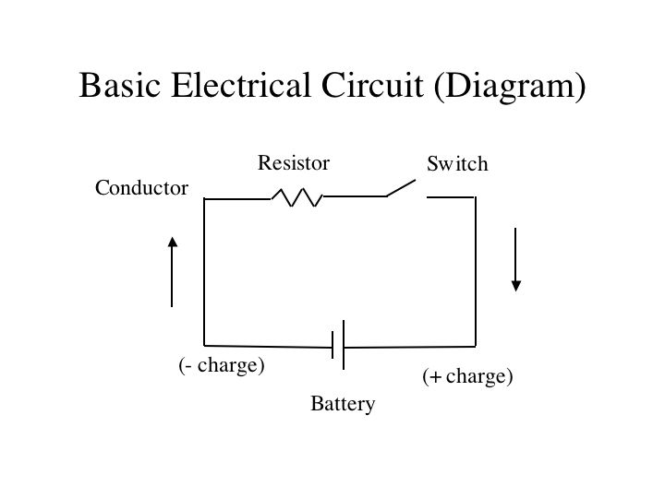

Squishy Circuits
Preparation: Make 3 batches of the dough ahead of time.
See videos for reference: https://www.youtube.com/watch?v=UDZo51k2BWQ#t=34
https://www.youtube.com/watch?v=5M3Dow20KlM

http://tinkering.exploratorium.edu/squishy-circuits

Conducting Dough recipe (Make 3 batches)
½ cup tap water
½ cup flour
2 tablespoons salt
1 ½ tablespoons cream of tartar
½ teaspoon vegetable oil
Food coloring
Mix in a medium pot. Constantly stir over medium heat until very thick. Knead on floured surface (careful, it will be hot) until it has the consistency of play doh.

Insulator Dough recipe (Make 3 batches)
½ cup flour
¼ cup sugar
1 ½ tablespoons vegetable oil
Mix and add distilled water
Mix dry ingredients and oil in a large bowl. Add water one tablespoon at a time until thick and doughy. Knead on floured surface until it’s the right consistency.
In addition to the dough, you will need the following materials for each group:

--AA or AAA Battery packs/wires
--LED light bulbs
Photo of set up for Squishy Circuits (one set of materials per group)
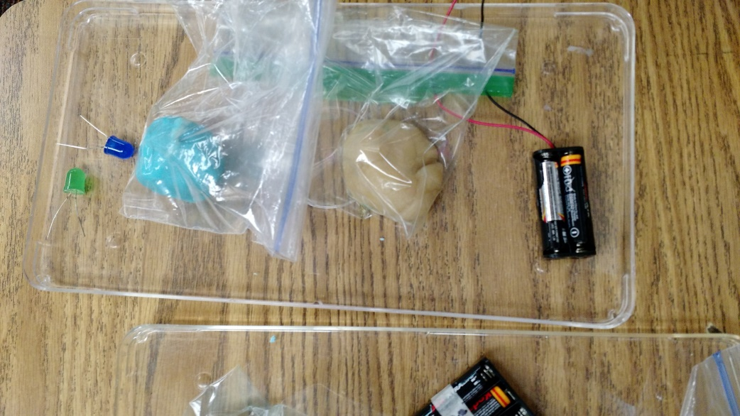

Procedure:
--Show the video: : https://www.youtube.com/watch?v=UDZo51k2BWQ#t=34 Start the video at 3:00 to skip the part about making the dough, since the dough will be made ahead of time.

--Stop the video at 5:35 and challenge the students to use the materials to make the LED light up.
Important reminders for students: Do not touch the two ends of the wires to each other. Do not hook up the LED directly to the battery. (These actions will ruin the materials so they won’t work.)

--After a few minutes of trying, show the rest of the video, then let them continue to experiment with making different shapes and circuits (for example, make an animals with light-up eyes). The dough can be re-used for other classes if the two colors are not mixed up too much.

