***Worm Investigation Experiment***

**Objective:**

Students will get the opportunity for hands-on observation and investigation of earth worms. The experiments will be used to encourage students to think about the importance of worms in the plant cycle as well as benefits to humans. Students will learn the parts of a worm and will gain respect for living creatures.



[**LS1.B: Growth and Development of Organisms**](http://www.nap.edu/openbook.php?record_id=13165&page=145)

* [Reproduction is essential to the continued existence of every kind of organism. Plants and animals have unique and diverse life cycles. (3-LS1-1)](http://www.nap.edu/openbook.php?record_id=13165&page=145)

[**LS3.B: Variation of Traits**](http://www.nap.edu/openbook.php?record_id=13165&page=160)

* [Different organisms vary in how they look and function because they have different inherited information. (3-LS3- 1)](http://www.nap.edu/openbook.php?record_id=13165&page=160)
* [The environment also affects the traits that an organism develops. (3-LS3-2)](http://www.nap.edu/openbook.php?record_id=13165&page=160)

**Docent Lab Guidelines:**

1. **Please emphasis to the students this is an experiment to observe and respect our living environment. The worms are not to be harmed in any way. They must be handled gently.**
2. **There are rubber gloves available for students who do not want to touch the worms. Tip: Do not offer them unless you really have a squeamish student. If you bring out gloves then everyone want them even if they were just handling the worm’s minutes before.**
3. **Schedule a date and time with your teacher to have the students come into the lab. Allow 1 at least an hour of class time.**
4. **Input the day and time into the Science Lab Master Schedule. Please make sure you add set up and clean up time to the class time.**
5. **Provide a brief discussion at the start of class. There will be a book available on the life cycle of worms if you would like to read it to the class. You can discuss the importance of worms to the plant and animal life cycle as you move through the experiment.**
6. **Check with the teachers to see if they would like to take their habitats back to the classroom or leave them in the Science Lab.**
7. **At some point during the class a worm will be in two parts (either by accident or intentional). Use this opportunity as a teaching lesson. Also most worms will continue to survive when they are cut in two pieces.**

_____________________________________________________________________________________

**General Docent Information – For Reference**

Earthworms have a lot of information to teach us. They play an important role in the environment, reduce waste and help vegetation grow by adding important nutrients to the soil. They are also interesting because they can regenerate parts of their bodies when needed.

**Worm Facts:**

There are about 6,000 different species of worms worldwide. One of the most is commonly known as the night crawler (it typically surfaces after dark), the angleworm (its makes popular bait for fishing) and the rain worm (it leaves waterlogged soil after storms).

Of the more than 180 earthworm species found in the U.S. and Canada, 60 are invasive species, brought over from the Old World, including the night crawler.

Lacking lungs or other specialized respiratory organs, earthworms breathe through their skin.

The earthworm’s digestive system is a tube running straight from the mouth, located at the tip of the front end of the body, to the rear of the body, where digested material is passed to the outside. Species vary in what they eat, but by and large their devouring of fallen leaves and/or soil allows the worms to move nutrients such as potassium and nitrogen into the soil.

The skin exudes a lubricating fluid that makes moving through underground burrows easier and helps keep skin moist. One Australian species can shoot fluid as far as 12 inches through skin pores.

Each earthworm is both male and female, producing both eggs and sperm.

Baby worms emerge from the eggs tiny but fully formed. They reach full size in about a year. They may live up to eight years, though one to two is more likely.

Full size for an earthworm varies among species, ranging from less than half an inch long [to nearly 10 feet](http://blog.nwf.org/2009/07/mysterious-three-foot-earthworm-up-for-protection/). The latter don’t occur in U.S. backyards—you’ll have to go to the Tropics to see one of them. The homegrown versions top out at around 14 inches.

The glaciers that crawled across Canada into the northern tier of the lower 48 states during the most recent ice age wiped out earthworms in those areas.

In other parts of the U.S., you may find native earthworm species, but the worms living in the regions scoured by glaciers are invaders from overseas, brought here intentionally by early settlers on the assumption that the worms would improve the soil, or carried accidentally in shipments of plants or even in dirt used as ballast in ships.

Worm movements within the Earth create burrows that encourage the passage of air and a loosening of the soil.

The northern forest evolved after the glaciers retreated, yielding an ecosystem that does not benefit from earthworms. These forests require a deep layer of slowly decomposing leaves and other organic matter called “duff” that overlays the soil. When [earthworms invade these forests](http://blog.nwf.org/2014/02/ten-things-to-know-about-earthworms/www.scientificamerican.com/article/invasive-earthworms-harm-forests-near-great-lakes/), they quickly eat up the duff, with the result that nutrients become less available to young, growing plants and the soil, instead of aerating and loosening, become more compact.

**Worm Anatomy**

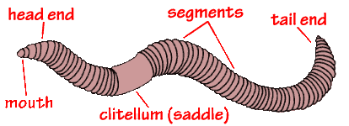

**Worm Cross Section**

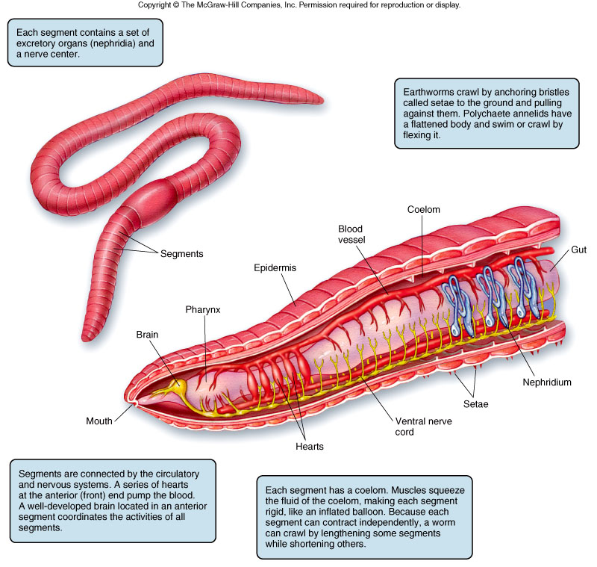

**Experiment #1: Worm Investigation**

***Estimated time: 25-30 minutes***

**Materials:**

* Clear plastic trays
* worms (one per student)
* Wet and dry paper towels
* Magnifying glasses
* Ruler
* Flashlights
* Piece of cardboard or dark construction paper
* red and blue colored film for the flashlight

**Preparation:**

* + Before class starts set the tables with the clear plastic trays, magnifying glasses, wet and dry paper towels.
  + The worms are stored in the refrigerator. They are packed in soil. Before class arrives take the worms out of the refrigerator and rinse them in the sink. Place them in a moist covered container until class arrives.
  + Hand out the worms when you are ready to start the investigation.

**During the Experiment:**

Hand out one worm per student. Walk through each step of this experiment with the class. Do each part of the experiment together. The section with the flashlight should be done by the docent with the students just observing since we are limited on the number of flashlights.

**PLEASE NOTE:**

Docents are not required to do all parts of Experiment #1 or all three Experiments. Pick and choose which ones you would like to do or all if you would like.

If the worms are inactive at the start of the class try dimming the lights and spraying them with room temperature water from the spray bottles. The docents will want to hang onto the spray bottles otherwise the students will over spray.

_____________________________________________________________________________

**Earthworm Anatomy**

Have the students place a moist paper towel in their tray. Next hand them a worm. They are to place the worm on the paper towel. Observe the worm as it moves. See if they can identify which end are the head and the tail. The leading part of the worm is called the **ANTERIOR** (where the head is) and the opposite end is called the **POSTERIOR** (where the tail is). Can they find the large band on the worm? It is called the **CLITELLUM**.

Carefully observe. Is this near the anterior or the posterior of the worm? The **Clitellum** is always located closer to the worms head (anterior side).

Roll the worm over and observe what happens. The side that the worm prefers up is called the **DORSAL** side. The downward side is called **VENTRAL** side.

Review: The four sides of the worm are the **anterior** (head side), **posterior** (tail side), **dorsal** side (top), and **ventral** (bottom).

**Earthworm under the Lens**

Option #1: Using the IPad as a magnifying tool. Soon to come to the Science Lab a clip on microscope for the IPad. There are a limited number of IPads so students will need to share.

Option #2: Using the Zoomy Microscope zoom into the details of the worm. In order view the worm you will have to place it between two pieces of plexi glass or clear vinyl cover sheets and gently press the sheets together so the worm is flattened out. There is only one Zoomy Microscope so this part will have to be done as a demonstration with the docent leading and the students observing. The Zoomy microscope is connected to the desktop computer. You will find directions on how to log-on to the computer and turn on the Zoomy at the desktop station. For a general overview of the Zoomy microscope check out this video; <https://www.youtube.com/watch?v=T4YFRQrc1jg>

**How Does a Worm Move?**

Have the students pick up their worm. Ask them to guess how a worm moves. Have them gently run their fingers along the bottom (ventral side) of the worm. Do they feel anything? On the bottom and side of the worm are groups of bristles called **Setae**. They are too small to see but you can feel them. The worm uses them to grip the ground of the walls of its burrow.

**Earthworm’s Behavior – Response to Touch**

Take a close look at the worms head or **anterior**. Do worms have any sense organs such as eyes, ears, noses or a mouth? Do you think the earthworm is capable of sensing….make a prediction?

To test an earthworm’s sensory behavior: Place a wet paper towel on one half of the tray and a dry paper towel on the other half. Place the worm in the middle of the tray stretched over both the wet and the dry towel. Wait 5 minutes to see which environment they prefer. Why do you think they prefer one over the other?

Take it one step further. Try this experiment several times before making a conclusion. The first time try it with the anterior (head side) on the wet paper towel. Next try it with the posterior (tail side) on the wet paper towel. Does it make a difference?

**Earthworm’s Behavior – Response to Light (Docent to do this portion only)**

To test an earthworm’s sensitivity to light: Place a wet paper towel on the tray. Cover half of the tray with a flat piece of cardboard or dark construction paper. Place the worm on the open end. Turn off the lights in the classroom. The docent will do the next part while the students observe. Turn on the flashlight and shine the light on the worm. What happens? Now repeat the experiment but this time place a red film over the lens of the flashlight. What happens now? Repeat again with a blue film.

Earthworm photoreceptors can detect the intensity of different colored lights. Earthworms move away from white or blue light especially if they lights are hot, but they do not react to red light.

Earthworm photoreceptors are located in nerve fibers in the skin. These nerve fibers are connected to special nerves called ganglia, which connect to an earthworm’s version of a brain. The brain, called a ganglion, helps trigger chemical reactions to control the entire body of the worm

**Experiment #2: Earthworms and Soil Group Activity (Optional)**

***Estimated time: 10 minutes***

**Materials:**

* 3 pots pre-filled with equal amounts of potting soil
* Seeds or seedlings
* Worms
* Labels
* Water

**Directions:**

1. Fill three pots with equal amounts of soil.
2. **Pot 1:** Add three seeds or seedlings in pot 1 and 2 worm. Add water. Label this as having 1 worm. Pick a volunteer from the class to bring up their worm and add it to the pot.
3. **Pot 2:** Add three seeds or seedlings in pot 2 and 4 worms. Add water. Label this pot as having 2 worms. Pick volunteers from the class to bring up their worm and add it to the pot.
4. **Pot 3**: Add three seeds in pot 3 and no worms. Add water. Labels this pot as having no worms.
5. Over the course of 4-6 weeks allow all the pots to grow with the same light and watering conditions. Docents to let the class and teachers know they are to water the plants. Observe and record the outcome and draw conclusions based on the results. The pots with the most worms should have the most growth because the worm’s waste material should make the soil more fertile. How does the worm’s effect on the plant directly affect humans and other planting eating animals?

**Experiment #3: Make a Worm Habitat (work in table groups, preferably 3 tables or this can be done as a group)**

***Estimated time: 10 minutes***

|  |
| --- |
| **Materials:**   * **Large Clear habitat container with a lid.** * **Worms (10-15 per group)** * **Sand** * **Soil** * **Grass or leaves** * **dark construction paper or dark cloth** * **tape** * **Rubber bands** * **spray bottle filled with water** * **Worm food: Kitchen scraps or mulched leaves or ground dry dog food.**   **Preparation:**  Before class starts prepare a tray(s) with the materials needed to make a habitat. Put holes in the lids of the container if there is none already.  After the Experiment #1 is completed remove the unnecessary materials from the table but leave the worms. Bring out the trays with the habitat materials.  **Instructions:**   1. Place the smaller plastic container upside down in the middle of the larger container. This will help prevent worms from burrowing into the container’s center and will keep them close to the sides where they can be observed. 2. Add a layer of sand to the bottom of the large container (approximately 1 inch). 3. Add a layer of soil. It is too dry spray with water. 4. Add another layer of sand and soil. Alternating but make sure you end up with soil at the top as the final layer. 5. Have students gently place the earthworms on the surface of the final layer. 6. Cover the top layer of soil with leaves. 7. Put on the lip and secure with rubber bands. 8. Earthworms like to live in the dark. Cover the sides of the habitat with black construction paper or cover with a dark cloth. 9. Store the habitat in a cool, shady spot in the classroom. DO NOT LEAVE NEAR THE WINDOW. 10. After several days remove the dark construction paper or dark cloth. Have the students observe the changes in the habitat. Be sure to replace the cloth or construction paper each time. 11. Check the soil every couple of days to ensure it does not dry out. Moisten with a spray bottle. 12. Once a week feed the earthworms with a very small portion of oatmeal, ripe fruit, vegetable scrapes or mulched leaves. 13. After 6-8 weeks return the worms to a garden.   **Follow up Questions:**   1. What did you observe? (The worms burrow and create tunnels) 2. What are the benefits of the tunnels? - They allow air and water to reach plants/roots in the soil. Worms fertile the soil by breaking down the organic matter into nutrients from the soil. 3. How are worms connected to plants and animals? – Worms help plants grow by allowing air and water to reach the roots. Worms are food for birds. |
| **Clean up Notes:** |

1. **Save unused portions of soil and sand.**
2. **Do not pour soil or sand down the drain.**
3. **Save unused worms in their original containers for other classes and place in the refrigerator.**