Grade 3—Sun, Moon, & Earth

Objective: Students will learn the basic characteristics of the sun, moon, and earth, and their relationships in our solar system.
From NextGen Science Standards-- Students who demonstrate understanding can:
5-PS2-1. Support an argument that the gravitational force exerted by Earth on objects is directed down. [Clarification Statement: “Down” is a local description of the direction that points toward the center of the spherical Earth.] [Assessment Boundary: Assessment does not include mathematical representation of gravitational force.]
5-ESS1-1. Support an argument that differences in the apparent brightness of the sun compared to other stars is due to their relative distances from the Earth. [Assessment Boundary: Assessment is limited to relative distances, not sizes, of stars. Assessment does not include other factors that affect apparent brightness (such as stellar masses, age, stage).]
5-ESS1-2. Represent data in graphical displays to reveal patterns of daily changes in length and direction of shadows, day and night, and the seasonal appearance of some stars in the night sky. [Clarification Statement: Examples of patterns could include the position and motion of Earth with respect to the sun and selected stars that are visible only in particular months.] [Assessment Boundary: Assessment does not include causes of seasons.]
Disciplinary Core Ideas:
PS2.B: Types of Interactions
- The gravitational force of Earth acting on an object near Earth’s surface pulls that object toward the planet’s center. (5- PS2-1)
ESS1.A: The Universe and its Stars
- The sun is a star that appears larger and brighter than other stars because it is closer. Stars range greatly in their distance from Earth. (5-ESS1-1)
ESS1.B: Earth and the Solar System
- The orbits of Earth around the sun and of the moon around Earth, together with the rotation of Earth about an axis between its North and South poles, cause observable patterns. These include day and night; daily changes in the length and direction of shadows; and different positions of the sun, moon, and stars at different times of the day, month, and year. (5-ESS1-2)

Docent Guidelines:
- Schedule a date and time with your teacher and the other docents. Plan about 60 minutes for this session.
- Input the date and time into the Science Lab Master Calendar. Remember to include about 30 minutes of set up and 30 minutes of clean up time, and add your name.

Important Notes:
This session is divided into 3 stations, so you will need 3 docents. At each station, the docent will teach a mini-lesson and conduct a brief activity. The students will rotate between stations, spending 10-15 minutes at each one. Remind teacher that Oreo cookies will be used and check for food allergies. Substitute appropriate snack for that student and they can observe another student’s Oreo.
After the stations, have the students complete the short quiz (if available) and review the answers together. You may want to have a short video ready in case you have extra time, or you could use a short video as an introduction.

Bill Nye Explains Seasons (4:57)—Great for docent review of the information for the Earth station
https://www.youtube.com/watch?v=KUU7IyfR34o

Earth and Sun, Kids Song by Silly Bus (4:00)—A fun intro for the beginning of the session
https://www.youtube.com/watch?v=MM01YJF8xT4

Here Comes the Sun: Crash Course kids #5.1 (3:03)—Show at the Sun station
https://www.youtube.com/watch?v=6FB0rDsR_rc

Apollo 11 Moon Landing (1:24)—Show at the moon station
http://www.sciencekids.co.nz/videos/space/moonlanding.html

Station 1—Earth

Materials needed:
- Globes
- Flashlights
- Copies of worksheet for creating the model of Earth, Sun, and Moon
- Crayons
- Scissors
- Bass fasteners (brads)

Procedure:
1. Briefly teach the following information (not all the details are necessary—focus on day/night and seasons/year). Use the globes and flashlight as visual aids, involving the students as much as possible with questions and participation.
2. Then have the students cut out and assemble their model of the earth and moon’s orbit of the sun. (See attached file). They can color it if there is time.

Day and night explained: Daytime is when you can see the sun from where you are, and its light and heat can reach you. Nighttime is when the sun is on the other side of the Earth from you, and its light and heat don’t get to you.
We get day and night because the Earth is turning and sometimes you can see the sun, and sometimes you can’t. It takes 24 hours for the world to turn all the way around, and we call this a day. Over a year, the length of the daytime in the part of the Earth where you live changes. Days are longer in the summer and shorter in the winter.

Extra Facts:
1. It takes 24 hours for the Earth to turn all the way around. That makes one day and one night.
2. At any moment, half of the world is in daytime and half is in nighttime.
3. The world is like a ball. We call the top half the Northern hemisphere and the bottom half the Southern hemisphere. The line between them is called the equator.
4. In the Northern hemisphere, we have summer in June, July and August and winter is in December, January and February.
5. In summer the days are longer than they are in winter.( In London, the longest day is about 16 hours and 39 minutes and the shortest is 7 hours and 45 minutes.)
6. In the Southern hemisphere the seasons are the other way around. When it is summer here it is winter there. Imagine celebrating Christmas on a long, hot summer day!
7. To help us understand where we are in the world, we also split the world into right and left halves called the Eastern hemisphere and the Western hemisphere.
8. The line between the Eastern and Western hemisphere’s is called the ‘Prime Meridian’ and it goes through Greenwich Royal Observatory in London.
12. The sun rises from behind the Earth in the East and sinks below the Earth in the West. The time when it appears is called sunrise, and the time when it disappears is called sunset. The length of time between sunrise and sunset is called daytime.
13. The Earth spins around an imaginary line that runs between the South Pole and the North Pole. This line isn’t completely straight – so, sometimes the North Pole is pointing away from the sun for long periods of time and it is always dark there, and sometimes the North Pole points towards the sun for long periods of time and it is always light there.
14. The Earth is also split into Northern and Southern hemispheres, which are divided by an imaginary line called the equator. The North and South poles are as far from the equator as you can get. Britain is in the Northern hemisphere and is slightly closer to the North Pole than it is to the equator.
15. In Britain we don’t have any days when it is always light or always dark, but the days are longer during the times of the year when the North Pole is pointing towards the sun and shorter when it is pointing away from the sun.
16. When the days are shorter, there is less time for us to get heat from the sun, so the weather is colder. This is why we get winter. When the days are long, there is more time for us to get heat from the sun so we get hot summer days.
17. Because the equator is halfway between the North and South poles, the days there are always 12 hours of daytime and 12 hours of nighttime. There is very little difference between the seasons.
18. In the Southern hemisphere the seasons are at opposite times to the Northern hemisphere. When it is summer here it is winter there, and when it is winter here it is summer there.
19. The shortest day of the year is called the winter solstice and the longest day of the year is called the summer solstice. There are two days each year where every place on Earth has 12 hours of daytime and 12 hours of nighttime. These are called the spring and autumn equinox.

Station 2—Moon

Materials needed:
- Phases of the moon charts
- Model to show orbit
- Oreos
- Paper plates, napkins, and plastic spoons
- Optional: iPad to show a short video of the Apollo 11 Moon Landing (1:24) http://www.sciencekids.co.nz/videos/space/moonlanding.html

Procedure:
- Teach the following information about the moon and explain the phases, using the visual aids provided in the kit.
- Then give each student one Oreo cookie and have them take off the top cookie layer. Explain that an Oreo will all the white filling is like a full moon, and a plain black cookie with no filling is like a new moon, when we can’t see the moon at all. Have them use the cookies to illustrate the phases of the moon. There are a couple different ways to do this: You could have the students use their top layer of cookie to cover up the white filling to show all the phases one by one, OR you could assign each student to create a certain phase (waning gibbous, for example) by scraping off the appropriate amount of filling with a spoon and then display them together. Or you could do both, if you have time. Of course, they can eat their cookies when they are all finished.
- Optional: Use the iPad to show a short video of the Apollo 11 Moon Landing (1:24) http://www.sciencekids.co.nz/videos/space/moonlanding.html

Moon Facts:
The Moon was probably made 4.5 billion years ago when a large object hit the Earth and blasted out rocks that came together to orbit round the Earth. They eventually melted together, cooled down and became the Moon. For another 500 million years pieces of rock kept striking against the surface of the Moon.
You can see the surface of the Moon by using a pair of binoculars or a small telescope. The Moon’s surface shows the damage caused by these large pieces of rock hitting it billions of years ago. The surface is covered in craters, pits and scars.
From the Earth we can only see one side of the Moon; the other side is always turned away from us. Photographs from space show a similar scarred surface on the other side.
The Earth has a much greater surface than the Moon and was also hit by debris (the rocks from explosions and collisions) but over time the damage has disappeared. The wind and rain in the Earth’s atmosphere has helped to erode the pits and craters.

The Moon has no atmosphere and so we can still see the damage caused billions of years ago.

If you look at the Moon when it is nearly full you can see the dark areas which are known as the seas. (They are all given Latin names, such as Mare Serenitatis – the Sea of Serenity, or Mare Frigoris – the Sea of Cold).These are not really seas but are huge expanses of smooth dark lava.

All parts of the Moon are lit in turn by the Sun. As it rotates round the Earth we see different fractions of the sunlit half, or hemisphere, of the Moon. These are known as the phases of the Moon, or lunar phases. The Moon changes from a thin crescent to a full moon and back again to a crescent in one month (actually 29 days, which is a lunar month).

The way the Moon revolves around the Earth makes the moon appear as if it is changing shape in the sky. The phases of the Moon depend on its position in relation to the sun and Earth as the Moon makes its way around the Earth. The Moon has eight phases and takes about 29.5 days to completely go through all the phases. The new Moon occurs when the Moon is between the Sun and the Earth forming a straight line. The entire moon is in shadow. A waxing crescent moon appears when sunlight shines on a thin crescent on the right side of the Moon. Next is the first quarter moon, which occurs when the moon moves ¼ of the way around the Earth and the right half of the Moon is lit. The waxing gibbous moon is next, which means more than half of the right side is lit. A full Moon occurs when the Earth is between Sun and the Moon, and the entire lighted side is facing Earth. Waning gibbous moon means that the amount of light is decreasing and a sliver of shadow shows on the right. The next phase is the last quarter moon when the Moon is lit on the left half. The final stage is the waning crescent Moon when there is a crescent of the Moon lit on the left side.

The waxing Moon. “Waxing” means growing. After the new moon appears in the sky as a tiny sliver of light the moon waxes. It grows into a crescent, curving to your left as you look at it and then into a half moon. This takes a week and so the period is described as the Moon’s first quarter.

The waxing gibbous Moon. Gibbous means humped and describes the shape of the Moon as it grows from a half moon to a full moon. Another week has passed and this is the Moon’s second quarter.

The waning Moon. “Waning” means shrinking. Now the Moon begins to get smaller again – it “wanes”. The third quarter takes us from a full moon to a half moon again, but this time it is the right hand side of the moon that shines.

The waning crescent Moon. The last quarter takes us from a half moon back to a crescent moon, facing right, and to a point where the moon disappears.

When the Moon is a crescent and only the crescent is being illuminated by the Sun, you can often see the shadow of the rest of the Moon. This is caused by reflection of sunlight from the Earth. It is sometimes called “the old moon in the new moon’s arms”.

Station 3—Sun

Materials needed:
- Sun chart/visual aids
- Copies of diagram of sun’s core
- Crayons
Optional: Ipad to show video about the sun: Here Comes the Sun: Crash Course kids #5.1 (3:03)
- https://www.youtube.com/watch?v=6FB0rDsR_rc

Procedure:
1.Teach the following information about the sun, or show the Crash Course Kids video on the ipad.
2. Show the students the playdoh model of the sun’s internal core.
2.Then have the students color and label the diagram of the sun’s core.

Sun Facts:
The Sun gives life to the Earth and the Earth would have no life at all without the energy it receives from the Sun.

The Sun is only one of millions and millions of stars in the Galaxy.

We see it as a large round red ball only because we are much closer to the Sun than to any of the other stars.

Other stars may be larger, brighter, smaller or fainter than our Sun but they are so very far away that we only see them as points of light in the night sky.

The Earth is one of nine planets that orbit round the Sun in what we call the Solar System.

Solar is the adjective from Sun and comes from the Latin word for Sun – sol, which also gives us the French soleil. (and the word for Sun in several mother European languages). Sol is the name of the star we call the Sun.

The Sun measures 2,715,395 miles (4.730,005 kilometers) right round (circumference).

The Sun is 92.96 million miles or 149.6 million kilometers from the Earth.

The Sun is bigger than can really be imagined, over one million times bigger than the Earth. This measurement is taken as one Astronomical Unit and is how we measure distances in our Solar System.

Like all stars, the Sun is composed of a great burning ball of gases. It is made of 92.1% hydrogen and 7.8% helium (helium is from the ancient Greek word helios, which means Sun).

• The center of the Sun is its core which produces all the Sun’s energy.

• Around the core is the radiative zone, which carries the energy out from the core.

• It takes about 170,000 years for the Sun’s energy to move from the core through the radiative zone to the next layer, the connective zone.

• From the connective zone, great bubbles move into the Sun’s surface, the photosphere.

• From the photosphere the Sun’s radiation escapes to the earth as sunlight.

• It takes about 8 minutes for the sunlight to be seen on the earth after it has left the Sun.

• Outside the Sun’s surface, or photosphere, are two further layers of light gases, the chromosphere and the corona (Corona means “crown” in Latin).

Sun videos:

Characteristics of the Sun (1:28)
http://www.pbslearningmedia.org/resource/ess05.sci.ess.eiu.sunbasics/characteristics-of-the-sun/

Here Comes the Sun: Crash Course kids #5.1 (3:03)
https://www.youtube.com/watch?v=6FB0rDsR_rc

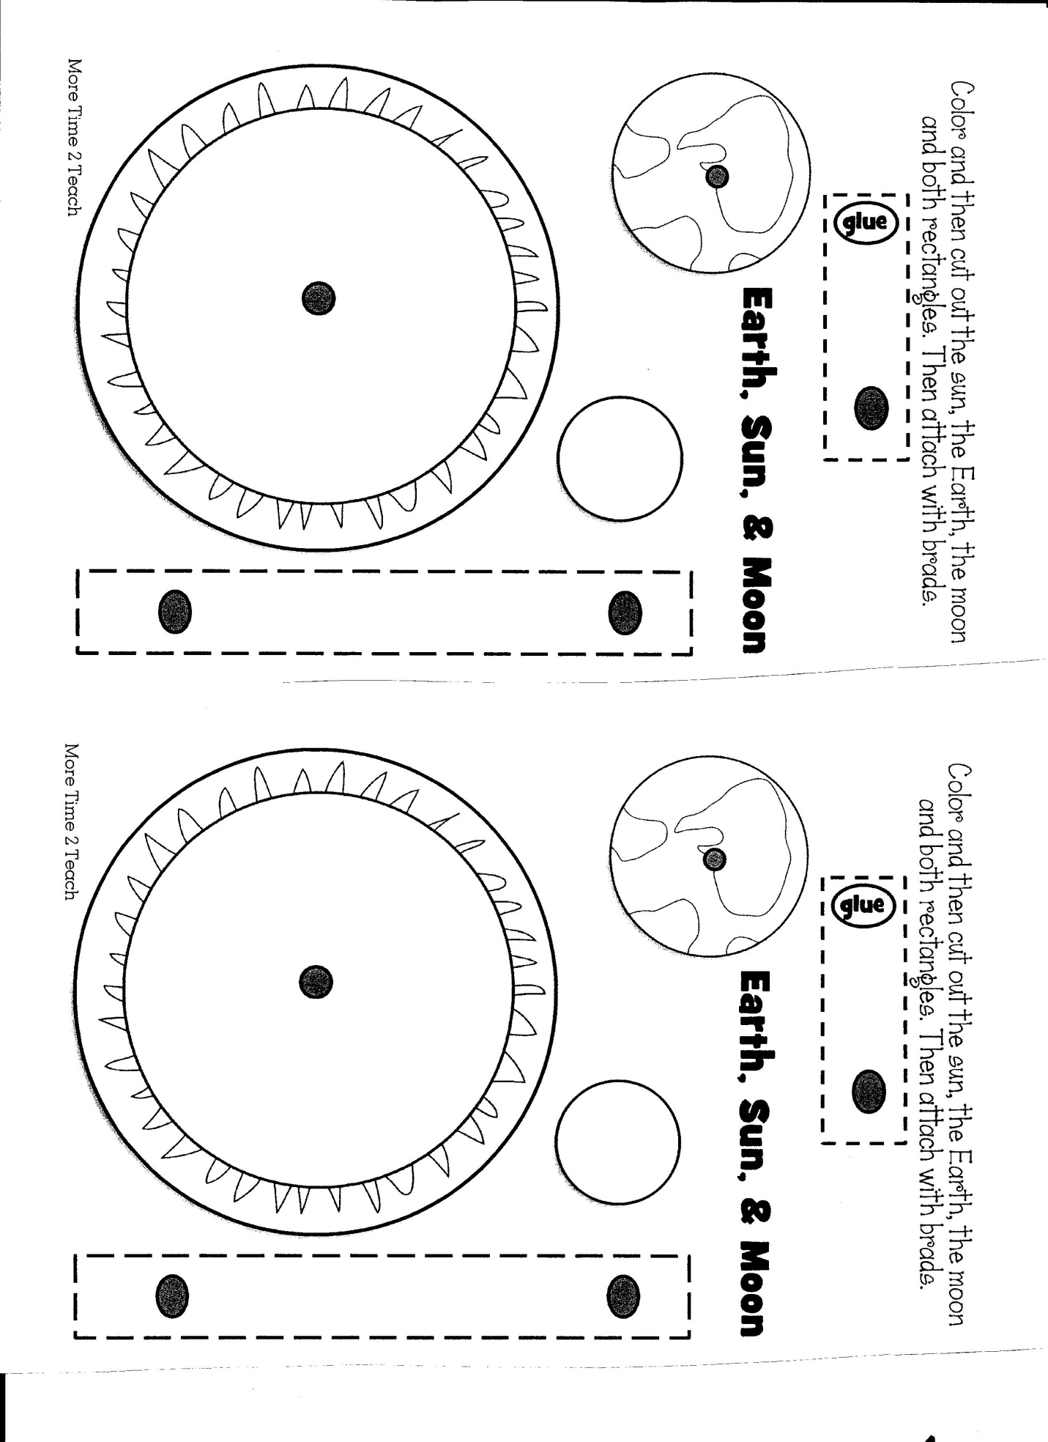
Name_______________________Teacher/Class______________
Earth, Sun & Moon Quiz
1) What shape are the earth, sun, and moon?
              - Round and flat
              - Cube-shaped
              - Sphere
  - Which is the largest: the earth, sun, or moon?
              - Earth
              - Sun
              - Moon
  - How long does it take the earth to travel once around the sun?
              - 24 hours
              - 28 days
              - 12 months
  - How long does it take for the moon to travel once around the earth?
              - 24 hours
              - 28 days
              - 12 months
  - How long does it take for the earth to turn once on its axis?
              - 24 hours
              - 28 days
              - 12 months
  - What part of the earth is in daylight?
              - The part facing the sun
              - The part facing away from the sun
              - The part facing the moon
  - Which of these is NOT true?
              - The sun rises in the east and sets in the west
              - The sun is highest in the sky at midday
              - The sun moved westward around the earth
  - Why does the moon seem to change shape?
              - Because it gets bigger and smaller
              - Because we only see the part of the moon that is lit by the sun
              - Because sometimes it is cloudy
  - Why, in some parts of the world, are the days longer in the summer than in the winter?
              - Because the earth is tilted as it rotates around the sun
              - Because the sun gets brighter in the summer
              - Because the earth spins more slowly in the summer

