Ferro Fluids
Safety Concerns:
- Ferro fluid is messy and will permanently stain clothes and fingers. Wear protective eye glasses, rubber gloves and an apron.
- Never ingest Ferro fluid.
- Neodymium magnets are very strong and fingers can be pinched between two attracting magnets. The magnets can slam together and crack. Wear protective eye glasses and rubber gloves when handling. It is best not to let the students play with the neodymium magnets or just give them one magnet at a time.
- Neodymium can demagnetize credit cards and effect cell phones. Try purses in the back of the room. Do not place the neodymium magnets near cell phones.
- Do not pour the Ferro fluid down the drain. If it needs to be discarded put it in the trash.
Helpful Hints when working with Ferro Fluids
- This photo shows the basic set up we found to work best demonstrating the lab. We used 2 plastic cylinder containers to hold up a low plastic tray. Inside the tray is a petri dish with the Ferro fluid.
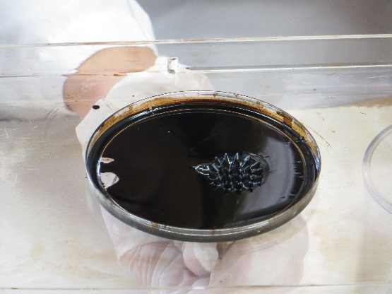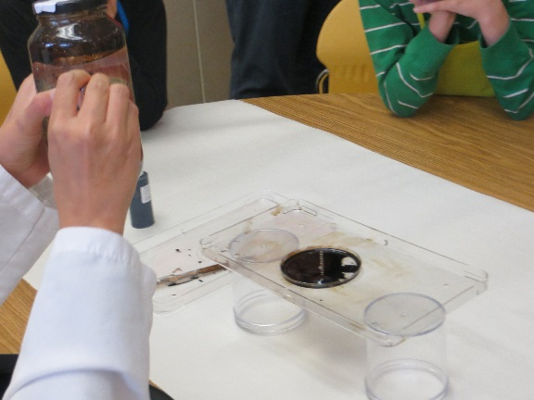
- Put this station near the counter. This way you can store your extra supplies within easy reach.
- Since the class will be rotation stations the best way to manage the messiness of this experiment is to have separate groups of materials prepared and placed on the counter for each group. For example if you have 3 rotations then put together three groups of each of the following materials: (1) low plastic tray, (2) petri dishes, (1) set of gloves, (1) pipette and (1) bolt. Have a trash can next to the table. As you finish with one group pick up the soiled set of materials on the tray and place them on the counter behind you. Remove soiled gloves directly in the trash. Then grab your next set of clean materials.
- For demonstration #2 listed below – Ferro fluid on the metal bolt: Place the neodymium magnet under the petri dish. There will be a magnetic charge between the magnet and the metal bolt. Keep the magnet in place while pouring on the Ferro fluid. You can remove the magnet to show the fluid will flow down to the bottom of the petri dish. BUT do not try to put the magnet back on. The fluid will splash out of the petri dish.
- This is a photo of demonstration #3 listed below.
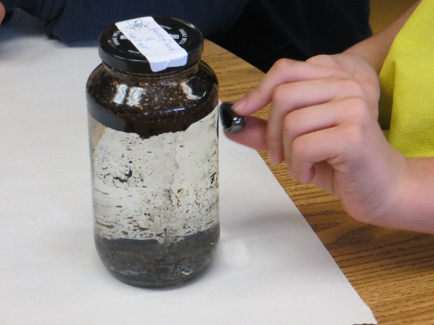
If the current glass jars with water and Ferro fluid do not work. The docents will need to create fresh jars. After a period of time the oil begins to separate in the water. Make sure the jars are labeled for safety purposes.
- Discuss the periodic table and show the students the symbol for iron and neodymium.
- If there is a sample of magnetite in the lab it can be used to show the students what it looks like. There should be a sample in the Rocks & Mineral kits.
Station 1: Ferro fluid Demonstration – (Group of 6-8 students)
Materials:
- Bottle of Ferro fluid
- Large metal bolt or screw and bolts
- Pipettes
- Neodymium magnets
- Bar magnets or other type of magnets (optional)
- Plastic trays with low rim
- Petri dishes
- Glass jar with a secure lid (like a jam, pickle or mayonnaise jar)
- Eye protection
- Rubber gloves
- Apron
- Plenty of paper towels or wipes
Procedure:
Demonstration #1 –
- Make sure all the students at the table as well as the docent are wearing apron, eye protection and rubber gloves for the entire demonstration.
- Pour a small amount of Ferro fluid into a petri dish or plastic tray. How does the surface of the fluid look?
- Carefully place the neodymium magnet under the petri dish or plastic tray. Have the students predict what will happen before you place the magnet under the petri dish. What is the difference in the surface of the fluid? Hypothesis why spikes appear?
- If bar magnets or other types of magnets are available repeat the experiment using them. Are the results the same?
- Recycle the Ferro fluid by removing the magnet and collecting the fluid using the pipette after the class is over.
Demonstration #2 –
- Use a separate clean petri dish for this demonstration.
- Assemble a large bolt with nuts or washers. Place them inside the plastic tray.
- Position the neodymium magnet(s) under the plastic tray and directly under the bolt. The magnetic current will flow through the bolt creating a magnetic field. You may need to place two books are something sturdy on each end of the tray to stabilize it.
- Have the students predict what will happen?
- Carefully and slowly pour Ferro fluid over the bolt using the pipette. What happens?
- Remove the magnets and recycle the Ferro fluid after class is over.
Demonstration #3 –
- Prior to the class starting fill a glass jar with water. Pour a small amount of Ferro fluid into the water.
- Tightly secure the top of the jar with a lid.
- Have the students describe how the Ferro fluid looks inside the jar and how it reacts with water? Does it mix with water (soluble)? The Ferro fluid will be attracted to the magnet, demonstrating the magnetic properties of the fluid.
- Carefully place the neodymium magnet near the surface of the glass jar and move it around the sides of the jar. What happens?
- If the docent feels comfortable doing so, she/he can pass the jar and the magnet around to each student so they get a chance to try moving the Ferro fluid around in the jar.
Docent Table Discussion Items:
What is a Ferro fluid?
Ferro fluid is a combination of tiny magnetic particles (typically magnetite) mixed with a carrier fluid like oil. The magnetic particles are extremely small. They are called nanoparticles. (Nano comes from a Greek words which mean minute.) These particles are microscopic. If the particles were too large they (1) would not create a homogenous mixture and (2) they would separate from the carrier oil in the presence of a magnetic field.

When were Ferro fluids created?
It was created in 1963 by a NASA scientist named Steve Papell. NASA needed a liquid rocket fuel that could be used in space. The goal was to create a rocket fuel to be used in a weightless environment, which could be drawn towards the pump using a magnetic field.
Is it a solid or a liquid?
It is both a solid and a liquid. There are solid pieces of magnetic particles suspended in a liquid.
What are the characteristics of Ferro fluids?
- React to a magnetic force field
- Ferro fluid is capable of operating in extreme temperatures, ranging from -55°C to 200°C (-67°F to 392°F), making them ideal for any location on Earth and particularly suited to space conditions
What is magnetite? Can you point out magnetite of the periodic table?
Magnetite is one of the most common oxide minerals and also one of the most common iron minerals. It is an important ore of iron and is found in igneous, metamorphic and sedimentary rocks.
What is a neodymium & a neodymium magnet?
Neodymium is number 60 on the periodic table. It is a silvery-white metal of the lanthanide series. Neodymium is a component of misch metal and some other alloys, and its compounds are used in coloring glass and ceramics.

A neodymium magnet is a rare-earth magnet, is a permanent magnet made from an alloy of neodymium, iron and boron. It is the strongest magnet in the world.
Why do spikes appear on the surface of the Ferro fluid in the presence of a magnetic field?
When a magnetic field is placed near the Ferro fluid the surface forms a regular pattern of peaks and valleys. This effect is known as the normal-field instability. A Ferro fluid forms spikes along the magnetic field lines when the magnetic surface force exceeds the stabilizing effects of fluid gravity and surface tension.
Some uses for Ferro fluid?
- Speakers
- Fast speed computer hard drives
- Satellites
- Rotating shaft seals
- Biomedical – researching is being done on using Ferro fluid for site controlled medicine in cancer patients.
- Research being done on how naturally occurring Ferro fluids in certain animal’s aid in their migratory senses.
Informational Videos on working with Ferro fluids:
http://www.bing.com/videos/search?q=science+tuesday+ferrofluids&FORM=HDRSC3#view=detail&mid=47EB4882995AB8D50A0947EB4882995AB8D50A09
http://mylespower.co.uk/2012/02/21/fun-with-ferrofluid/

