Packing for a Year on the International Space Station
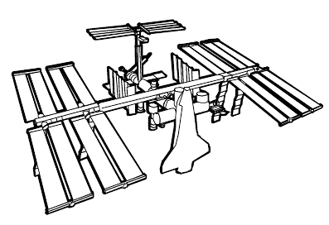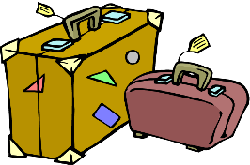
THE GOAL:
Your team has been selected to live and work on the International Space Station (ISS) for a year. You will be conducting lots of experiments while on the ISS. Before you fly into space your team needs to decide what to pack. Assume all your basic needs for air, food, water and warmth are met with the basic design of the ISS. What else would you pack to meet any special needs, entertainment and to keep you happy?

THE REQUIREMENTS:
- All your items for your entire crew must fit inside a 1 cubic meter box.

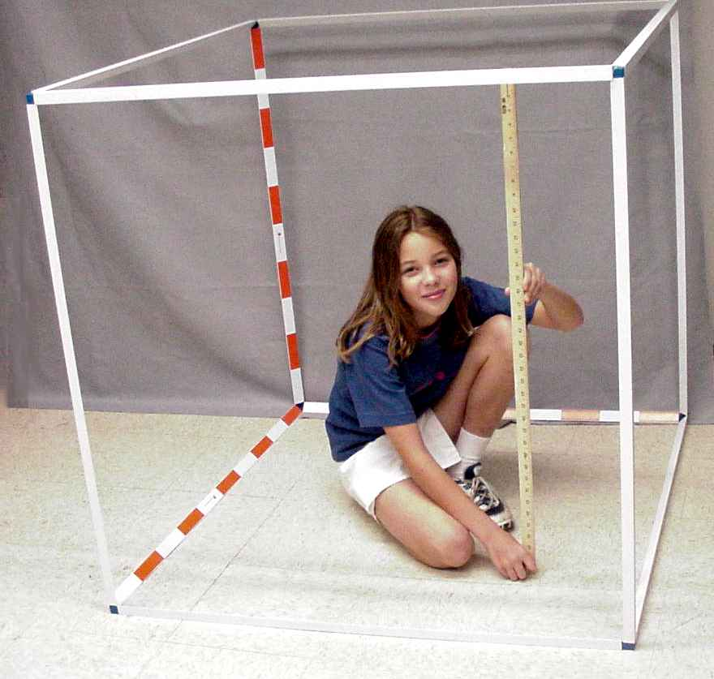 1 cubic meter box
- For electronics you must take enough batteries to last 2-1/2 years.
- There are no electronic repair shops on the ISS. If it breaks you must know how to fix it.
- There is no cell phone service in space.
- There is no internet / Wi-Fi in space.
- There is no cable and satellite TV in space.
- The weight of your items doesn’t matter since there is no gravity.
- Once you decide what you are going to take confirm everything will fit in the ONE BOX.
- You can draw the items (to scale) on large pieces of paper and put them inside your box.

PACKING LIST:
- _________________________________________________________________
- _________________________________________________________________
- _________________________________________________________________
- _________________________________________________________________
- _________________________________________________________________
- _________________________________________________________________
- _________________________________________________________________
- _________________________________________________________________
- _________________________________________________________________
- _________________________________________________________________
- _________________________________________________________________
- _________________________________________________________________
- _________________________________________________________________
- _________________________________________________________________
- _________________________________________________________________
- _________________________________________________________________
- _________________________________________________________________
- _________________________________________________________________
- _________________________________________________________________
- _________________________________________________________________

