Underwater volcano
Objective:
Students will learn about underwater volcanoes, recognizing that there are different types of volcanic eruptions
Docent Lab Guidelines:
- Schedule a date and time with your teacher to have the students come into the lab. Allow at least 1 hour of class time. Ideally it would be better if you can get 1hr. 15 min. or 1-1/2 hrs.
- Input the day and time into the Science Lab Master Schedule. Please make sure you add set up and clean up time to the class time.
- Watch the video for docents to see what the experiment demonstrates=
- Allow 30 minutes to set up and 30 minutes of clean up time.
_____________________________________________________________________________________
General Docent Information about the Subject Matter – For Reference
California’s Next Generation Science Standards (NGSS) for K-12
Alternative Discipline Specific Course
Grade Six – Earth and Space Sciences
April 2014

MS-ESS1 Earth’s Place in the Universe
Construct an explanation based on evidence for how geoscience processes have changed Earth’s surface at varying time and spatial scales. [Clarification Statement: Emphasis is on how processes change Earth’s surface at time and spatial scales that can be large (such as slow plate motions or the uplift of large mountain ranges) or small (such as rapid landslides or microscopic geochemical reactions), and how many geoscience processes (such as earthquakes, volcanoes, and meteor impacts) usually behave gradually but are punctuated by catastrophic events. Examples of geoscience processes include surface weathering and deposition by the movements of water, ice, and wind. Emphasis is on geoscience processes that shape local geographic features, where appropriate.]

Informational Videos:
https://www.youtube.com/watch?v=ml5uolY9rFI shows an explosive underwater volcano off Tonga
https://www.youtube.com/watch?v=TAfPFrLXywo underwater volcano in the Caribbean

https://www.youtube.com/watch?v=NkPHpu65Pjc convection currents
https://www.youtube.com/watch?v=nsayFUSwKfs “It’s raining film canisters!” for docents
https://www.youtube.com/watch?v=6q7N8-Nh4pA for docents

Vocabulary
Effusive: where lava flows like a thick, sticky liquid up to weeks at a time. In effusive eruptions, degassing is common but ash is usually not.

Explosive: where fragmented lava explodes out of a vent over a short and infrequent period of time. In explosive eruptions, the fragmented rock is often accompanied by large amounts of ash and gases that are suspended into the atmosphere.

Viscosity: the resistance of a fluid to flow. Fluids with a high viscosity resist flow, the typical response in explosive eruption styles (e.g. Mount St. Helens). Fluids with a low viscosity flow freely, typical in more effusive eruption styles (e.g. Hawaiian or Icelandic shield volcanoes or the Columbia River flood basalts).

Docent led discussion
Elicit from students that from their study of Erosion, there are also very rapid and very slow changes to the earth’s surface: Landslides and slumps vs creeps and scouring by wind; the creation of sea arches vs the effects of a tsunami
Time is relative in earth science; change of some type is inevitable.

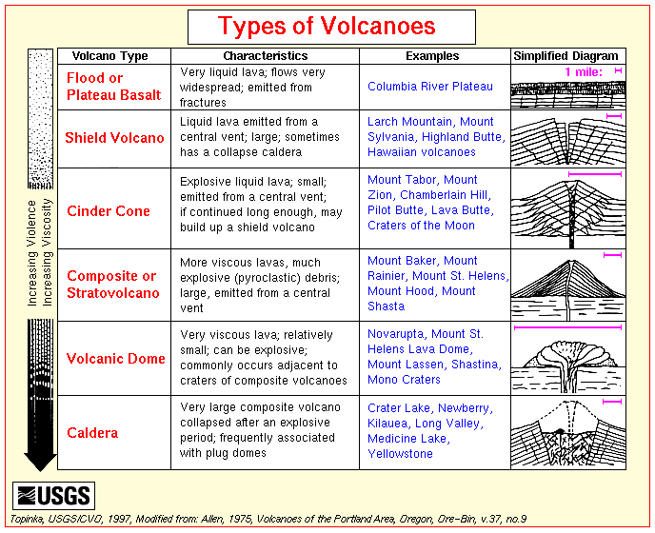

Experiment #1: Make an effusive underwater volcano (non-explosive)
Estimated time: 15-20 minutes
Materials Needed:
- Food coloring
- A small piece of aluminum foil
- Small clear flask
- Large beaker (or clear glass container)
- pencils to poke small hole in aluminum foil
- paper towels to mop up small spills
Convection currents are a tough subject to teach and to understand, but this science demo makes it a heck of a lot easier. Almost everyone will have these materials to do the science experiment in their home.
Preparation:
- Before class starts set out water to be at room temperature for the larger, clear container.
- Heat water in the microwave for the small glass jars – to be added just before students perform the experiment
- Prepare small squares of aluminum foil to cover the small glass jars.

Instructions:
- Students will fill large containers no more than three-quarters full
- Students will place 3-4 drops food coloring in small jars, then add heated water.
- Students will cover small jars with aluminum foil, sealing the foil around the opening
- Students will poke small hole, no larger than the pencil, into the foil
- Students will carefully lower small container straight down into the larger one without tipping it
- Students will observe the warm water rise to the top, illustrating the convection currents that are observable from an underwater volcano

Safety Concerns :
- Remind students to handle the small clear flask carefully, as it will be warm.

Experiment #2 Make two types of volcano

MATERIALS (1 per student unless stated otherwise):

- Safety Goggles
- Aprons (optional)
- Eruption Styles handout, 1-2 per table
- Baking soda (~1 tsp per student)
- Vinegar (1 gallon should be enough for each student to conduct the two eruption styles)
- Alka-Seltzer tablets (½ tablet per student)
- Dawn dish soap
- Film canisters
- Dixie cups
- Trays on which to place erupting volcano

Safety Concerns:
Warn students to step back after they have put the lid on their canister. They should never put their face directly over the canister. Never aim the canister at others.

Estimated time: 15-20 minutes
Phase I

1. Give each student a Dixie cup and film canister. The Dixie cup will be used to produce an effusive eruption and the film canister to produce an explosive eruption.

- Pour vinegar into the Dixie cup to ~2/3 full. Add a squeeze of Dawn dish soap and mix carefully. Next add 1 tsp of baking soda to the mixture. Place Dixie cup on tray for observations. A reaction should occur immediately.

- Describe to a partner exactly what you observed.

Phase II

- Fill the film canister half way with vinegar. Give each student a half of an Alka-Seltzer pill (or a whole for a more explosive eruption) to put in their film canister. Once they drop the tablet in, the student should immediately and firmly put the lid on and step back. It typically takes a few seconds for the pressure to build up before it erupts. The tighter that the seal is on the container the more dramatic the eruption will be.

- Describe to a partner exactly what you observed.

Docents: the reaction is much more dramatic if the container is set upside down. If you do this, either whole class or as a demo afterwards, we suggest that you do it outside.

Debrief: These are both caused by chemical reactions.
Volcano 1: the baking soda (a base) reacts with the vinegar (an acid)
Volcano 2: the Alka-Seltzer tablet combines with the water to release carbon dioxide, which as a gas, expands.
Remind them they ca “Go climb a volcano” right here in California. Mt Lassen, a National Park, is the southernmost volcano in the Cascade chain. It is about 3 hours to the north of us.

