Pond Identification Sheet

Protozoans and Small Animals

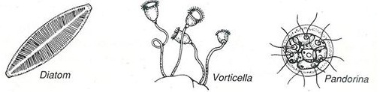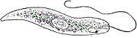Euglena
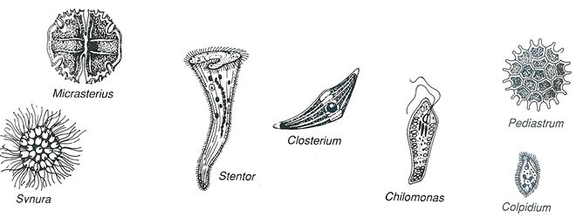
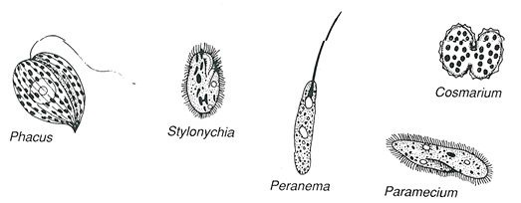
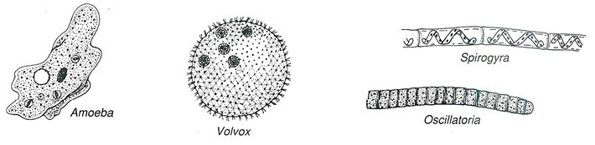
Pond Identification Sheet

Protozoans and Small Animals

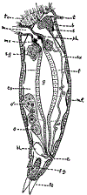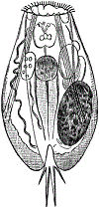Rotifers 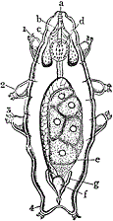Waterbear (tardigrade)
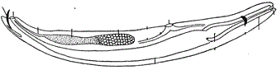Nematode 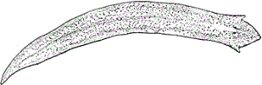Planarian
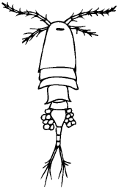cyclops 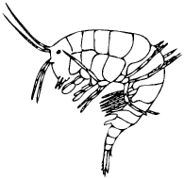water shrimp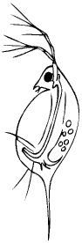water flea (Daphnia)

Algae and Other Microorganisms
Volvox (green)Haematococcus (red colored)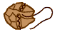dinoflagellate (red, green, some multicolored)

Desmids (green)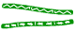Spirogyra (green)

Anything green and stringy can be classified as an algae!!!

