Name: ___________________________________________

Build a Simple Closed Circuit
Instructions

Objective:
Build a circuit board with a simple switch to control the flow of energy in a closed circuit. Work in teams of 3-4.
Materials:
- Cardboard
- 1 – LED light
- 1 – 3 Volt Button Cell Battery
- Metal brads
- Paperclips
- Electrical tape or white tape
- 2 – Alligator clips
- Scissors
- Markers
- Wood Skewer
Instructions:
- The idea is to use the brads and paperclips as your wires
- Power! Pick the place on your board were you want the battery. For example at the bottom of the board.
- Place a paperclip on the spot where your battery will be located. Using your skewer punch a hole just inside the ends of the paper clip.
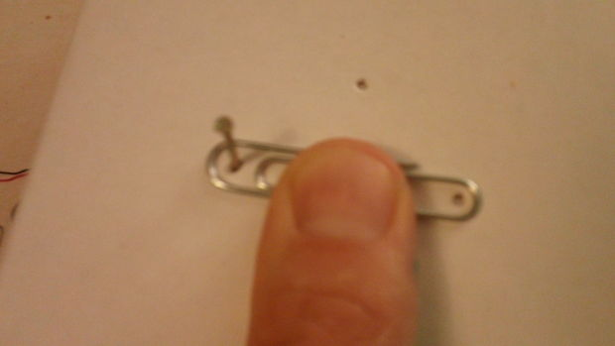
- Rotate the paperclip 90 degrees and punch 2 more holes.
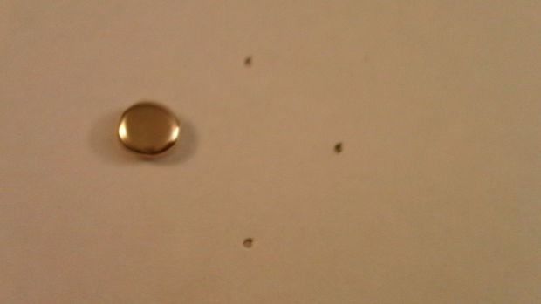

- Push a brad through the left hole and another through the right hole. The legs of the brads will stick out the back of the board. Connect a paperclip thru the legs of the brads and flatten the legs down as shown. This will become your negative connection.
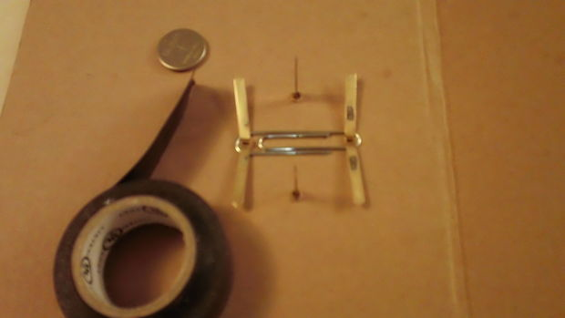

- Place tape over the flattened brads.
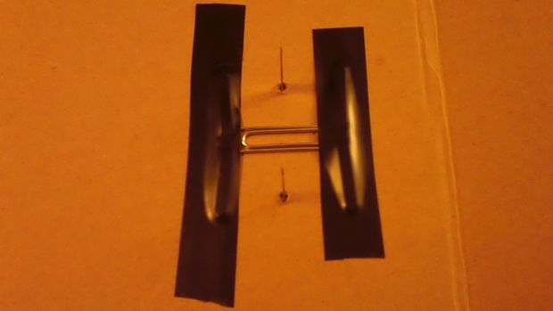

- Place two more beads on the top and bottom holes. But do not flatten yet.
- Next place your 3V battery on top of the paper clip. Make sure the (+) POSITIVE side is facing you (facing up).
- Attach a paperclip thru the legs of the brads. The battery will be sandwiched between the two paper clips. Flatten down the legs of the two remaining brads.
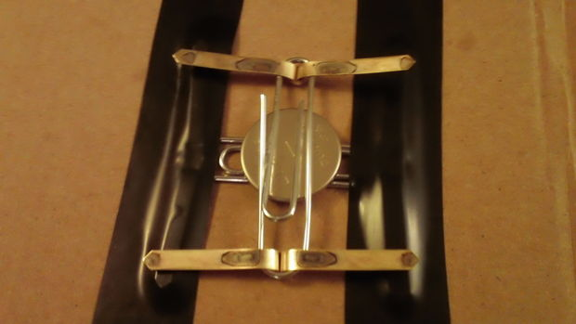

- Tape the battery as shown below.
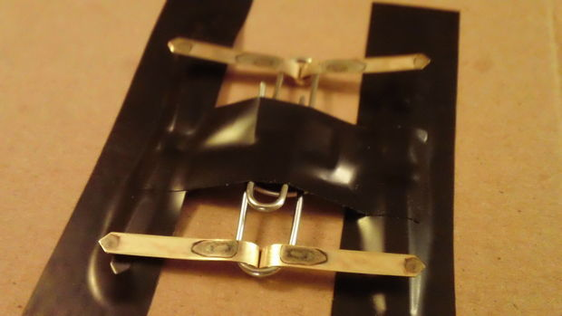

- Before taping the other two brads, turn the board over so you are looking at the front face of the board and test the connection.
- To do this slip a paperclip over the head of the top and right brads. These paper clips will remain on the board. You may have to push the brad head up to get the paperclip to slip over it.
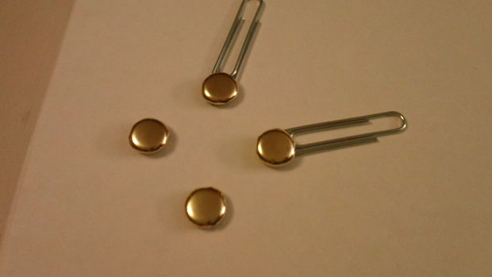

- To test the battery connection take two alligator clips. Attach one alligator clip to each paper clips as shown.
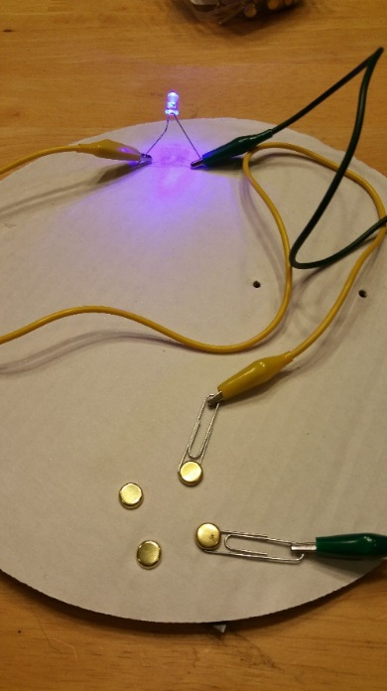

- Attach the other end of the alligator clip to the LED. (NOTE: The LED has a long and a short leg. The LONG LEG IS POSITIVE. With a marker note which brad is positive and which one is negative. If it lights you can move on. See the diagram above.
- Remove the LED and the alligator clips.
- The first paperclip coming off the positive pin (the top one) will be used to make the ON/OFF switch. It is not to be connect directly to the next brad. Leave the top of this paperclip free to slide from side to side.
- Directly above this ON/OFF switch add 4 more brads and 3 paperclips in a line. Punch the hole directly inside the paperclips then add the brads. See diagram.
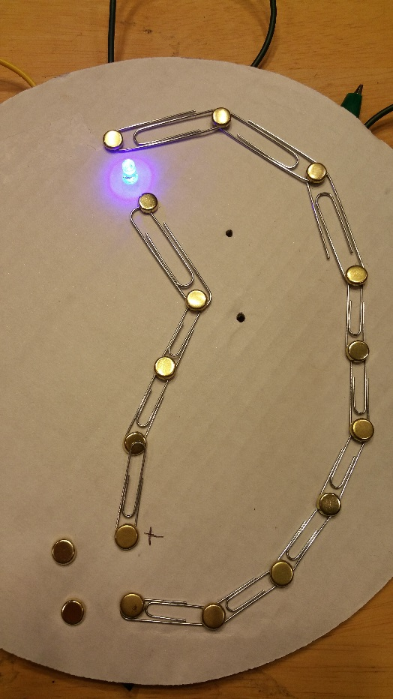

- Next create the NEGATIVE line. Use 8-9 paperclips and 9-10 brads. Punch the holes and add the brads the same way you made the POSTIVE line. But angle the last 1-2 paperclips in this line 90 degree so that the top brads on the POSTIVE line is directly above the brad from the NEGATIVE line, making sure to leave space between them for the LED light. See the diagram above.
- Punch a hole with your skewer in the center of the space between the top brads. This hole will be for the LED.
- Slide the legs of the LED into the hole.
- The LED needs to be installed the right way. The POSITIVE leg is longer than the negative leg. Wrap the LED POSTIVE leg (or wire) around the POSITIVE leg of the brad. Then wrap the LED NEGATIVE leg (or wire) around the NEGATIVE leg of the brad as shown.
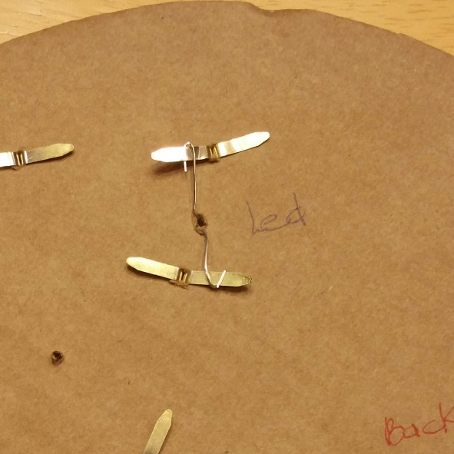
- You will want to tape all the legs of the brads and the LED. But before you do that test your circuit board to make sure all your connections and contact points are correct.
- Turn your board over to the front side.
- Rotate your “switch” over to the on position. This means the paperclip will have to make contact with the ON brad (your ON button).
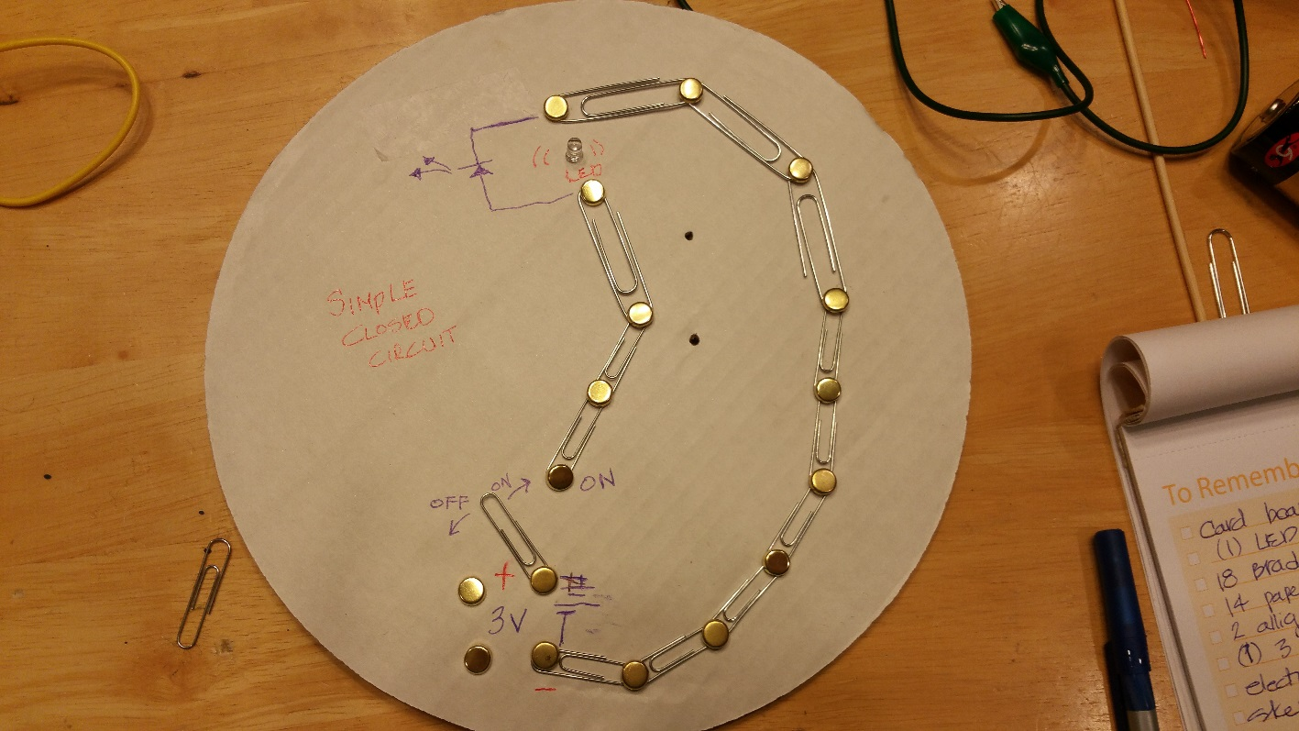
- The light should go on. If not, check to see if the LED is installed correctly and is making contact with the brads.
- Congratulations if you got your circuit to light.
- Next turn your circuit board over and tape all the brads. The back side of your board will look something like this before it is taped.

- On the front face of your circuit board label the LED, ON/OFF switch, positive (+) line, negative (-) line, 3V battery.
WhooHOO you did it!!!!! You are ready for 5th Grade!!!!!

Trouble Shooting:
If you can’t get your circuit board to work, it could be one of the following things…..
- The battery is dead.
- The battery came loose. Tape it in there snug.
- There is a short. Look on the back and make sure there is no metal tabs or pins that have rotated and are touching each other.
- There is a loose connection between the paperclip and the brad. Make sure the brads are bent down hard and tight.
- There is a loose connection at the switch. It may help to make the moving paperclip be below the other paperclip it is connected too.
- Wrong polarity. This could be that the battery or LED are in backwards.

